Peer Support Group
Please be aware that this section of the website is still under development. Thank you.

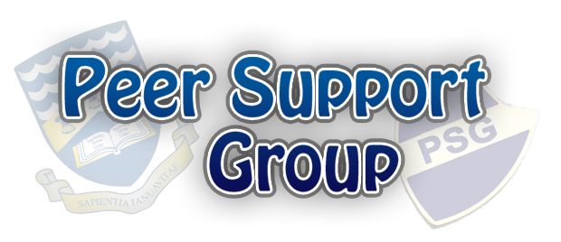

Welcome!
The Peer Support Group is a group of sixth form students who are dedicated to ensuring that the school community is enjoyed by everyone. Not only do we help with organisation of events such as the Year 7 Charity Quiz, but the vast majority of our time goes towards mentoring Year 7s and making sure that they are settled and happy in WGSB. We not only do this during the transition, but also through the year, with each Teaching Group having two dedicated PSG reps that they meet regularly. Our PSG make a positive contribution to the safeguarding of pupils at Wirral GSB.
We can help students from all years, with any issues they may have, whether they be related to homework, friendships, bullying issues or personal worries. We are there when a student may feel more comfortable talking to someone of a similar age, who has been through the same things only a few years ago, as opposed to a teacher. We work closely with Mrs Smith (our Learning Mentor) and the Anti-Bullying Committee to ensure that the school community is a safe and enjoyable environment, and strive to make a positive difference to students' lives.

Prince Diana Award (two years on the run!)
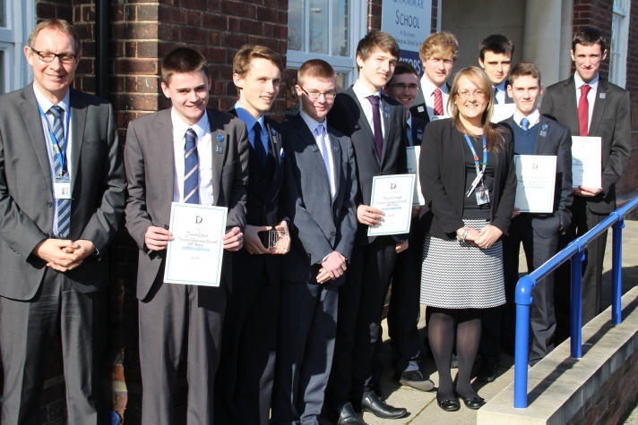
The PSG was recently awarded the Diana Award, a prestigious organisation that officially recognises inspirational young people. The PSG were awarded the Diana Award for the Champion Volunteer' category, for young people who give their time to improve the lives of others.
You can read more about the award on the news story on the school website, which you can reach by clicking here.
The Diana Award was awarded for a second time in 2017, this time in recognition of the innovative ways in which the Peer Support Group had chosen to raise funds for charity by completing the Three Peaks Challenge.

Contact the PSG
Students: You can contact the PSG either through the Learning Mentor (Mrs Smith), or by speaking to any PSG reps either during form time or break/lunch. You can always stop us in the corridor too and ask to arrange a meeting or grab a quick word - we're always happy to talk to you!
Remember that, if you are in Year 7, your PSG reps will visit you at least every fortnight during your Teaching Group session. This is another great chance to grab a chat with your rep regarding any issues/concerns you have... or just for a nice conversation!
Parents: If you are a parent looking for more information about the PSG, use the contact details below. You can also ask your son's Head of Year, or email any of the staff, details for those closely related to the PSG can be found below.

Contact Details

Mrs Smith, Learning Mentor - asmith@wirralgrammarboys.com
Mr P Harrison, Deputy Head - pharrison@wirralgrammarboys.com
Mr Atkinson, Head of Year 7- oatkinson@wirralgrammarboys.com
You can also contact the school by phoning 0151 644 0908, or by emailing schooloffice@wirralgrammarboys.com

